**Hbase Assignment -Task 2**

1. **Access the hbase data from hive.**

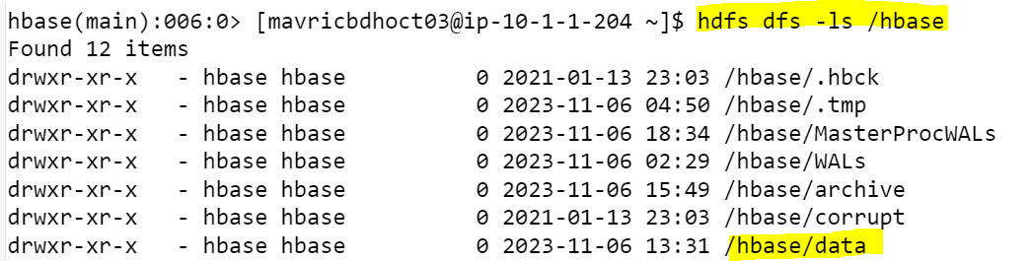

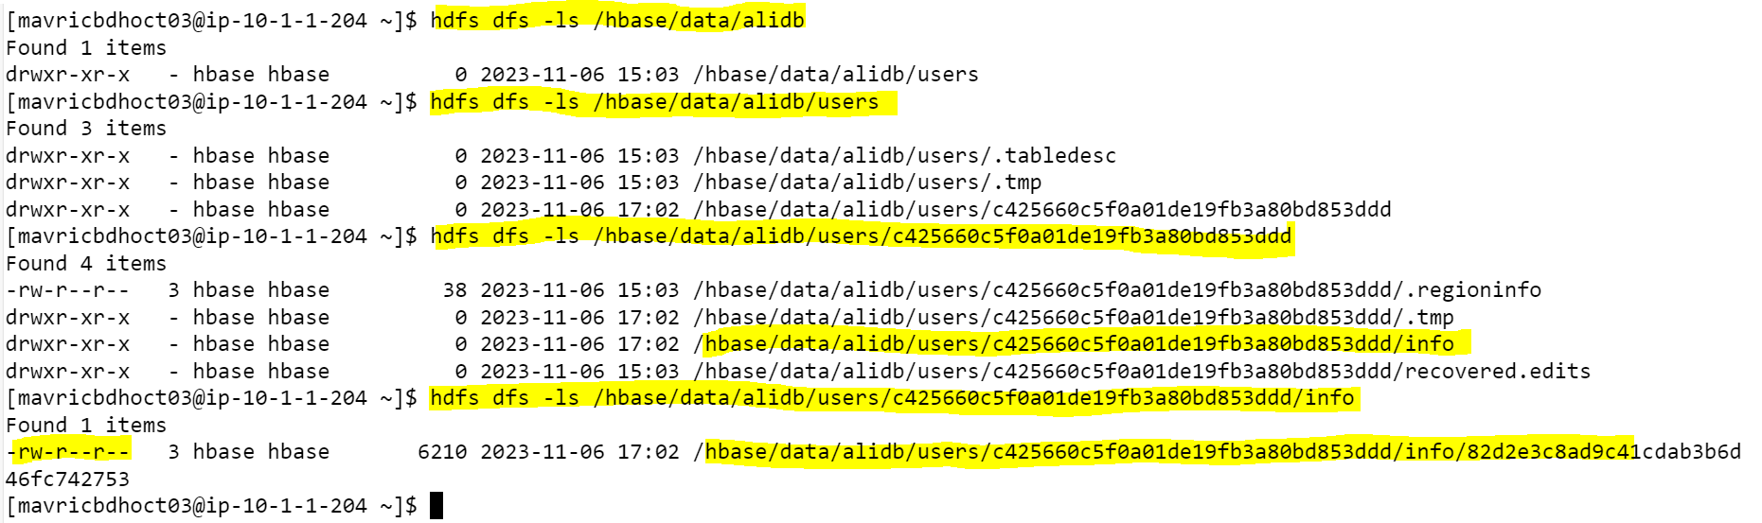

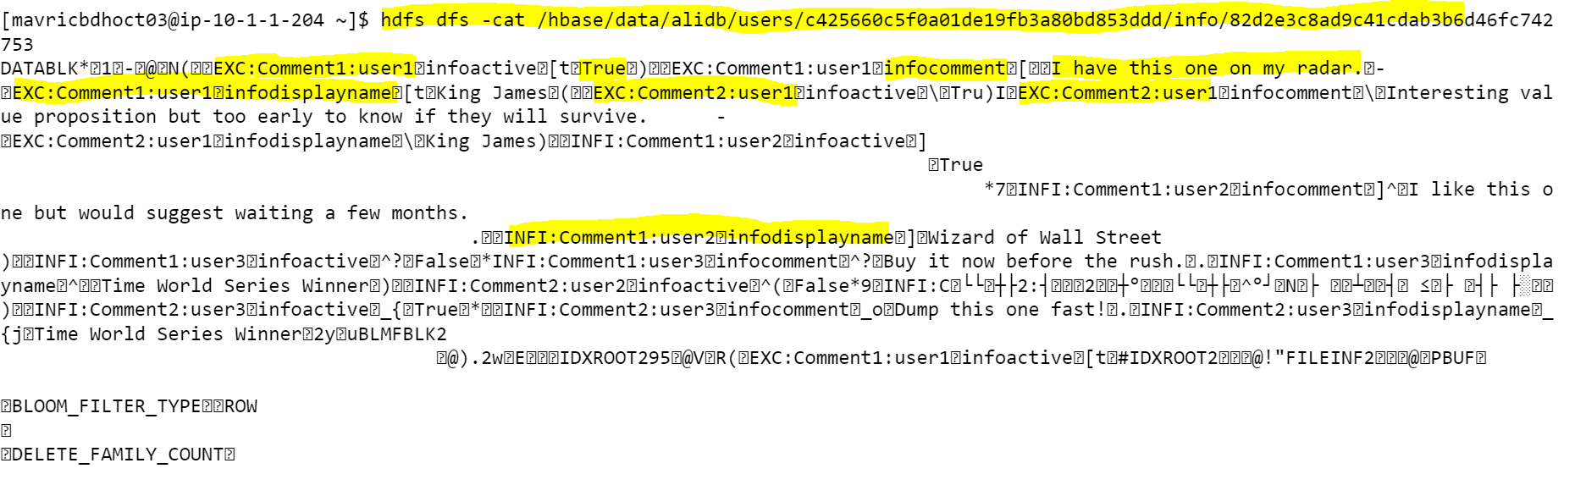

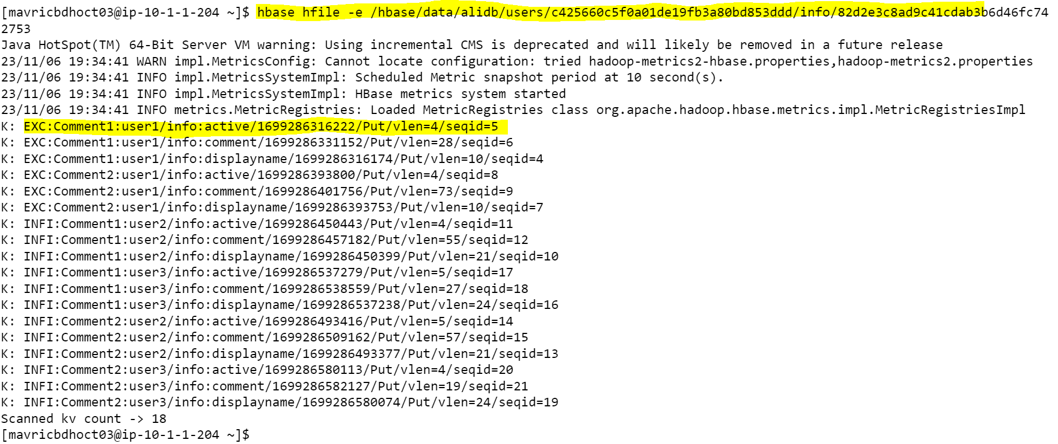

1. **For the above hbase table create a corresponding hive table and access the data by running queries in hive.**

